**Experiment No.: 7 Date: 20-03-2023**

**AIM**: Familiarization of linux commands.

**CO2**: Perform system administration task.

**Procedure:**

1. Expr : Evaluate the given expression and display the result

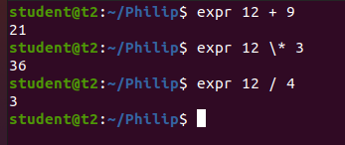

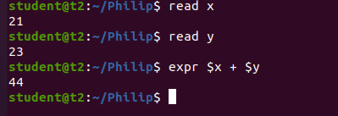

2. df : Get a report on system disk space usage

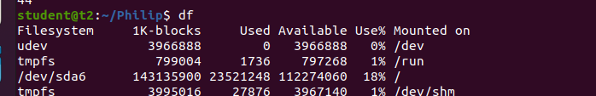

3. du : used to checks how much space a file or dir takes in the current directory



4. Create new user:

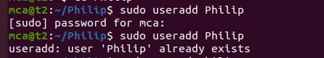

Change password of new user :

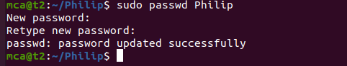

Create new group



Sudo usermod -G : Add user to group



id username : Used to find user group name and numeric id



To display all the groups

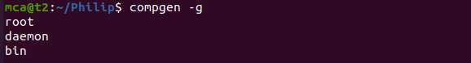

chmod : used to change the access permission of the file and directories.

It stands for change mod

Read – r

Write – w

Execute – x

Denying the permission

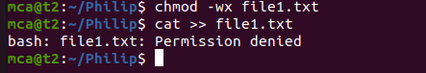

Allowing the permissions

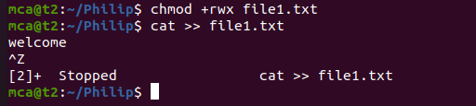

Chown : Used to change the file ownership or directory ownership for a user or group

And chown stands for change owner

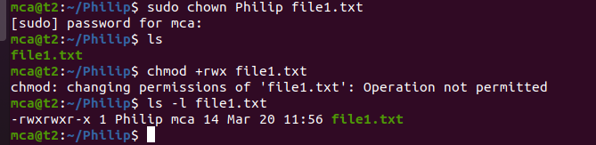

Delete user

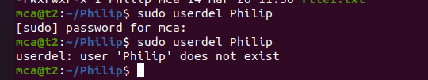

Delete group

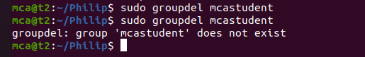

**Result**

The program was executed and the result was successfully obtained. Thus CO2 was obtained